Jonothan Meyer
Linear Regression
Project 6
03/31/21

Exercise 1 (6 points): Using male subjects from the teengamb data, fit a model with
gamble as the response and the other variables as predictors.

(1) Predict the mean amount gambled by all males with average (given these data) status,
income and verbal score using a 95% confidence level.

teengamb_M <- teengamb %>% filter(sex == 0)
summary(teengamb_M) #Mean: stat = 52, income = 4.9, verbal = 6.8, gamble = 29.775

gamb_status.lm <- lm(gamble~status+income+verbal, data=teengamb_M)
mean_predictors <- data.frame(status=52, income=4.9, verbal=6.8)
predict(gamb_status.lm, mean_predictors, interval="confidence", level=0.95)

The estimated lower end of the 95% confidence interval for an average male teen gambler is 19.06 pounds per year. The estimated upper bound for the same subject and same confidence interval is 39.7 pounds per year based on the 'teengamb' data.

(2) Predict the amount that a randomly sampled male with average (given these data)
status, income and verbal score would gamble using a 95% confidence level.

predict(gamb_status.lm, mean_predictors, interval="predict", level=0.95)

The estimated lower bound prediction interval for a randomly sampled average male teen gambler is -26.18 pounds per year. In this context there is probably an asymptotic at 0 for the lower bound, so that is most likely the actual estimated lower bound. The estimated upper bound for the same male is 84.94 pounds per year.

(3) Repeat the previous part for a male with maximal values (for this data) of status,
income and verbal score. Which prediction interval is wider and why is this result
expected?

min_predictors <- data.frame(status=18, income=.6, verbal=1)
max_predictors <- data.frame(status =75, income=15, verbal=10)

predict(gamb_status.lm, min_predictors, interval="prediction", level=0.95)
The estimated gambling prediction interval for teen male with minimum status, income, and verbal lifestyle is -39.53 pounds per year. Similar to question two the actual lower bound is most likely 0 based off the context of the data. The estimated gambling upper bound for this same male is 91.15 pounds per year.

predict(gamb_status.lm, max_predictors, interval="prediction", level=0.95)
The estimated gambling prediction interval for teen male with maximum status, income, and verbal lifestyle is 10.87 pounds per year. The upper bound for this same male is estimated at 143.94 pounds per year.

(4) Predict the amount that 25 males with average (given these data) status, income and
verbal score would gamble in a year using a 95% confidence level.

Xstar <- t(c(1,mean(teengamb_M$status), mean(teengamb_M$income), mean(teengamb_M$verbal)))

b<-coefficients(gamb_status.lm)
tval<-qt(1-(1-.95)/2,28-4)
X<-model.matrix(gamb_status.lm)

c(t(Xstar)%*%b-tval* (699.78*(1/25+t(Xstar)%*%inv(t(X)%*%X)%*%Xstar))^.5,
t(Xstar)%*%b+tval* (699.78*(1/25+t(Xstar)%*%inv(t(X)%*%X)%*%Xstar))^.5)

The estimated lower bound gambling prediction interval for 25 average teen males is 14.75 pounds per year. The estimated estimated upper bound for the same average teen males is 44.8 pounds per year.

Exercise 2 (6 points): Use the same predictors from the previous exercise (status, income
and verbal score for males) to fit model of the square root of the gamble variable. Complete
each part of Exercise 1 using the transformed gamble variable as your response. Take care
to interpret the intervals in terms of the original units of the response variable.

gamble_root <- teengamb_M
gamble_root$gamble <- sqrt(teengamb_M$gamble)
#Rebuild Linear model using altered gamble response
gamble_root.lm <- lm(gamble~status+income+verbal, data=gamble_root)

predict(gamble_root.lm, mean_predictors, interval="confidence", level=0.95)
The estimated lower bound gambeling confidence interval for the square root of an average teen male is 3.43 pounds per year. The estimated upper bound is 5.28 pounds per year.

predict(gamble_root.lm, mean_predictors, interval="prediction", level=0.95)
The estimated lower bound gambeling prediction interval for the square root of an average teen male is -.612 pounds per year. Once again, for the context this probably means the actual lower bound is 0. The upper bound of the same prediction interval is 9.32 pounds per year.

predict(gamble_root.lm, min_predictors, interval="prediction", level=0.95)
The estimated gambling prediction interval for teen male with square root minimum status, income, and verbal lifestyle is -2.19 pounds per year. Similar to question two the actual lower bound is most likely 0 based off the context of the data. The estimated gambling upper bound for this same male is 9.53 pounds per year.

predict(gamble_root.lm, max_predictors, interval="prediction", level=0.95)
The estimated gambling prediction interval for teen male with square root maximum status, income, and verbal lifestyle is 3.2 pounds per year. The upper bound for this same male is estimated at 15.1 pounds per year.

c(t(Xstar)%*%b-tval* (699.78*(1/25+t(Xstar)%*%inv(t(X)%*%X)%*%Xstar))^.5,
t(Xstar)%*%b+tval* (699.78*(1/25+t(Xstar)%*%inv(t(X)%*%X)%*%Xstar))^.5)
The estimated lower bound gambling prediction interval for 25 square root average teen males is -10.63 pounds per year. The estimated estimated upper bound for the same average teen males is 19.41 pounds per year.
Exercise 3 (8 points): This is Exercise 7(a)(b)(c)(d) from Chapter 3 of the textbook
Linear Models with R. The F-test required for part (c) is not covered in these notes, but is
covered in the textbook readings.

(1) Fit a regression model with Distance as the response and the right and left leg
strengths and flexibilities as predictors. Which predictors are significant at the 5%
level?

punt <- punting
Constructing our linear model using 'Distance' as response, and 'Right Leg Strength', 'Left Leg
Strength', 'Right Leg Flexibility', and 'Left Leg Flexibility' as the predictors.
punt.lm <- lm(Hang~RStr+LStr+LFlex+RFlex, data=punt)

summary(punt.lm) #Relevant info from summary function:
Predictor | P-Value
RStr | 0.52
LStr | 0.37
RFlex | 0.73
LFlex | 0.42

The P-Value for all of the predictors is >.05, so using this model none of the predictors are identified to be significant at the 5% level.

(2) Use an F-test to determine whether collectively these four predictors have a relationship to the response.

The F-test results in a P-value of .00492, so at the 5% we can conclude that these four predictors collectively have a relationship to the response.

(3) Relative to the model in (1), test whether the right and left leg strengths have the
same effect.

P-values after comparing ANOVA tables of different linear models using right and left predictors
Predictor | P-Value
RStr | 0.32
LStr | 0.73

At the 5% significance level neither of these two predictors are identified to be significant. However, the right leg seems to have a higher effect on the response than left leg strength because .32<.73

(4) Construct a 95% confidence region for (Beta_RStr, Beta_LStr). Explain how the test in (3)
relates to this region.

Building our Confidence Region for Beta_RStr, Beta_LStr.
library(ellipse)
plot(ellipse(punt.lm,c(2,3)),type="l", main= "(Beta_RSt, Beta_LSt) Confidence Region")
points(coef(punt.lm)[2], coef(punt.lm)[3], pch=19)
abline(v=confint(punt.lm)[2,],lty=2)
abline(h=confint(punt.lm)[3,],lty=2)
points(0,0, col="Red")

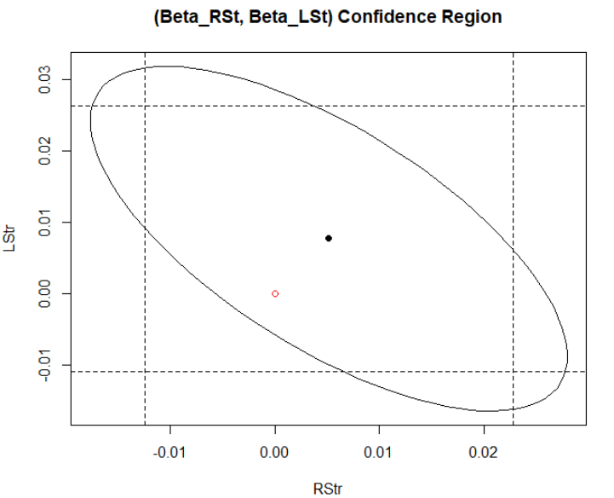
This relates to part 3 by visually illustrating that when paired together for a linear model RStr and LStr are reject at 95% confidence. This is shown by the origin Red[(0,0)] inside the bounds of the oval. Additionally in terms of proximity of the origin the center of the oval is closer horizontally to the origin than vertically. This illustrates that right leg strength has an estimated greater effect on the response than left leg strength because the x-axis represents the effect of right leg strength.

